Serial number of technical requirements for medical device:

THIS DOCUMENT IS PROVIDED BY THE APPLICANT/THE REGISTRANT

**ACE Blade 700**

1. **Product specification**
   1. Product specification table

|  |  |  |  |  |
| --- | --- | --- | --- | --- |
| Model | Electrode width | Electrode length | Sterilization method | Shelf life |
| ME725M1C | 0.27cm+0.003/-0.008cm | 6.35cm | Ethylene oxide | 3 years |
| ME725M1E | 0.27cm+0.003/-0.008cm | 6.35cm | Ethylene oxide | 3 years |
| ME7251C | 0.27cm+0.003/-0.008cm | 6.35cm | Gamma ray radiation | 3 years |
| ME7251E | 0.27cm+0.003/-0.008cm | 6.35cm | Gamma ray radiation | 3 years |

Model naming:

ME725M1C

ME refers to Megadyne

7 refers to Ace blade 700

25 refers to 2.5 inches, the electrode length, which is equivalent to 6.35mm mentioned in table above

M refers to modified electrodes

1C refers to a C interface

ME725M1E

ME refers to Megadyne

7 refers to Ace blade 700

25 refers to 2.5 inches, the electrode length, which is equivalent to 6.35mm mentioned in table above

M refers to modified electrodes

1E refers to an E interface

ME7251C

ME refers to Megadyne

7 refers to Ace blade 700

25 refers to 2.5 inches, the electrode length, which is equivalent to 6.35mm mentioned in table above

1C refers to a C interface

ME7251E

ME refers to Megadyne

7 refers to Ace blade 700

25 refers to 2.5 inches, the electrode length, which is equivalent to 6.35mm mentioned in table above

1E refers to an E interface

* 1. Schematic diagram:
     1. Schematic diagram of product

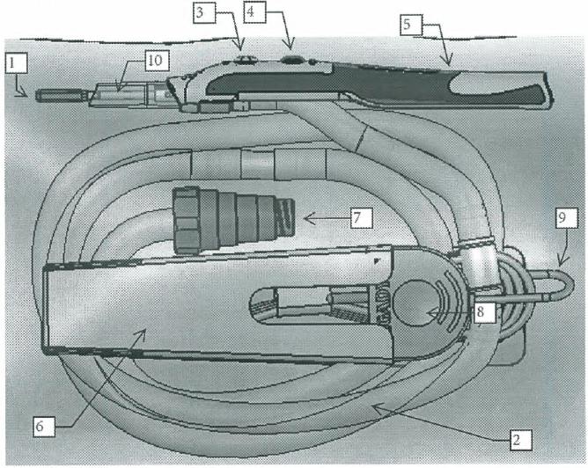

|  |  |
| --- | --- |
| Component | |
| 1. Electrode | 1. Protective sleeve |
| 1. Exhaust pipe | 1. Exhauster connector |
| 1. Cut button | 1. Generator connector |
| 1. Coagulation button | 1. Connecting power cord |
| 1. Electrosurgical pencil body | 1. Gray sumitomo A4 heat-shrinkable tube |

* + 1. Schematic diagram of electrode:

Standard electrode:

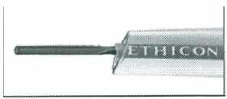

Modified electrode:

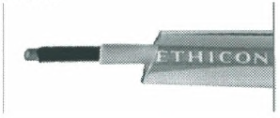

* 1. Materials in contact with patients

|  |  |
| --- | --- |
| Blade | 305 stainless steel |
| Shaft and tip insulation | Polyolefin, PTFE |
| Electrode coating | PTFE (Polytetrafluoroethylene) |
| Pad printing | Ink, (Marabu TPU970) |
| End cover | Vinyl, TPE (green) |
| Modified electrode distal tip insulation | PTFE |
| Nose cone | Silicone rubber |

1. **Performance indicators**
   1. Safety properties
      1. The general requirements for safety of surgical electrode shall comply with the requirements of GB 9706.1-2007. For the safety characteristics, see Annex A.
      2. The particular requirements for safety of surgical electrode shall comply with the requirements of GB 9706.4-2009.
      3. The EMC requirements of surgical electrode shall comply with the requirements of YY 0505-2012 and Clause 36 in GB 9706.4-2009.
   2. Appearance
      1. The surface of the electrosurgical pencil shall be clean and free from spots, as well as the rough surface causing damages.
      2. The surface of electrode shall be free from rusting, corrosion spot or other surface defects.
      3. The surface of the exhaust pipe shall be clean without any manufacturing defects.
   3. Sterility
      1. Electrosurgical pencil body, electrode and exhaust pipe shall be sterilized.
      2. Ethylene oxide residues: The EO residues of parts in contact with the patient shall not exceed 10 μg/g.
   4. General properties
      1. The length of the electrosurgical pencil body is 14.43 cm, with the allowable error of ± 0.1cm.

The length of electrode is 6.35 cm, with the allowable error of ± 0.03 cm.

The length of the connected power cord is 3 m, with the allowable error of ±15.2 cm.

* + 1. Continuity of electrode: The electrode shall be well connected to the host cable and the impedance value shall be less than 50 Ω.
    2. The hardness of metal parts of electrode (component 1) shall not be less than 120HV0.2
    3. The surface roughness (Ra) of electrode (component 1) shall be not bigger than 0.5 μm.
    4. After the corrosion resistance test is completed, the corrosion degree of electrode (component 1) shall be lower than the value listed in Class B requirements for boiling water treatment specified in YY/T 0149-2006.

1. **Test methods**
   1. Safety properties:
      1. Conduct the test on the general requirements for safety of surgical electrode according to the method specified in GB 9706.1-2007; the result shall comply with the listed requirements.
      2. Conduct the test on the particular requirements for safety of surgical electrode according to the methods specified in GB 9706.4-2009; the result shall comply with the requirements of 2.1.2.
      3. Conduct the test on the particular requirements for safety of surgical electrode according to the methods specified in YY 0505-2012 and Clause 36 in GB 9706.4-2009; the result shall comply with the requirements of 2.1.3.
   2. Appearance inspection:

Perform a visual inspection and hand feeling test; the result shall comply with the requirements of 2.2.

* 1. Sterility test
     1. Conduct the test according to the method specified in the Chinese Pharmacopoeia (Edition 2015, Volume IV); the result shall comply with the requirements of 2.3.1.
     2. Ethylene oxide residues: Conduct the test according to the method specified in GB/T 14233.1-2008; the result shall comply with the listed requirements.
  2. General properties

**Annex A**

Product characteristics

1. Classification according to the degree of protection against electric shock: Not applicable
2. Classification according to the type of protection against electric shock: Type CF
3. Classification according to the degree of protection against liquid ingress: Not applicable
4. Classification according to the safety degree of product used in the flammable anesthesia gas mixed with air, oxygen or nitrous oxide: Not applicable
5. Classification according to the operation mode: Not applicable
6. Rated voltage and frequency of equipment: Not applicable
7. Input power of equipment: Not applicable
8. This equipment has no defibrillation-proof applied part;
9. This equipment has no signal output or input part;
10. Permanently installed equipment or non-permanently installed equipment: Non-permanently installed equipment;
11. Electrical insulation diagram (Not applicable, with the host)
12. Rated voltage of accessory: 5.5kVp